Roadmap for Freelancers

First of all, thank you for taking the time to read this. I understand that freelancing comes with challenges, but with the right guidance and strategies, you can truly excel in the field and achieve financial freedom.

# Roadmap for Freelancers ( Steps )

Step 1: Set Clear Goals and Priorities

Step 2: Market Yourself Effectively

Step 3: Build a Strong Portfolio

Step 4: Deliver High-Quality Work and Communicate Well

Step 5: Invest in Continuous Learning

I have divided the entire process into five steps. Let's begin with the first step on the next page.

## 1- Set Clear Goals and Priorities

Define what you want to achieve with your freelancing career, such as income targets or types of projects. Prioritize tasks and clients that align with these goals to stay focused and motivated.

For example, a freelance graphic designer might set a goal to earn $5,000 per month and prioritize working with tech startups to build a portfolio in that niche.

Once you find your niche, you will transition from walking to running. When someone knows their destination, they can set their own pace based on the path they choose.  
  
For example, you can check out this company with a single focus.  
  
<https://100xelevate.com>  
  
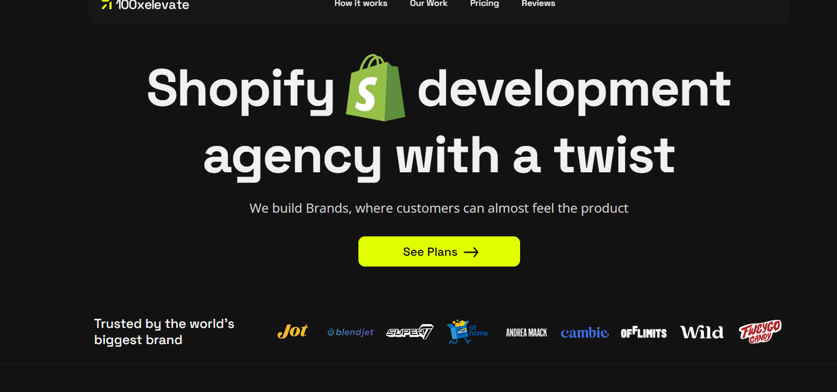

On niche selection, I have a YouTube recording available, I will recommend you watch that if you still have questions.

<https://www.youtube.com/live/F2X3NXEnd_A>

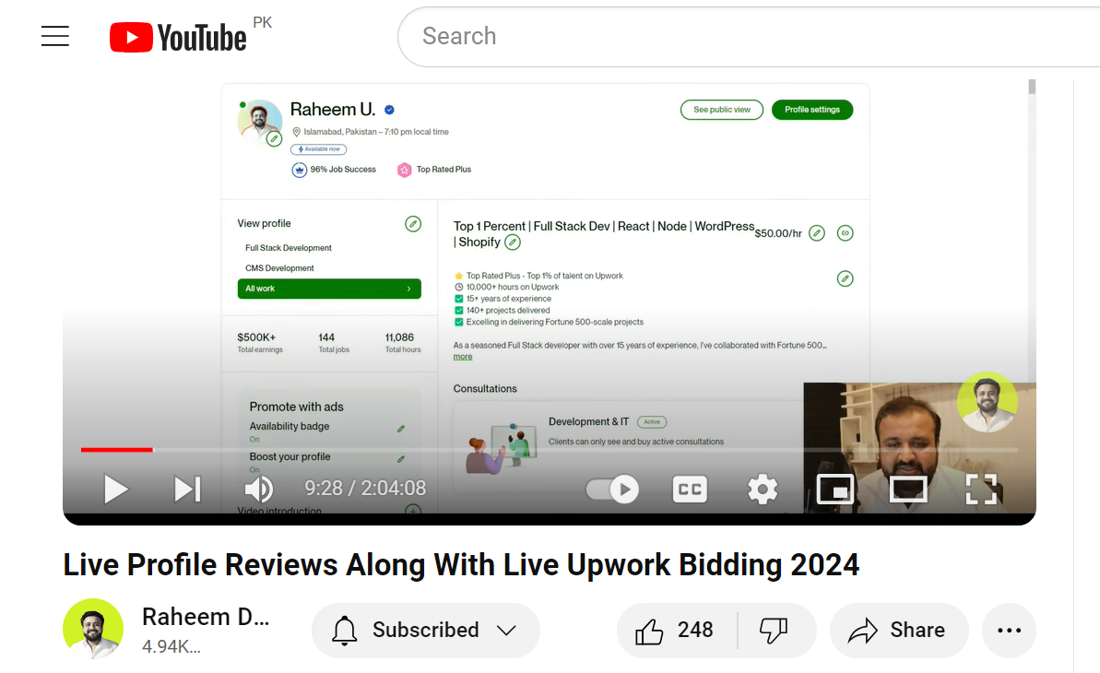

I know it's a long video but it has value in it.

## 2- Market Yourself Effectively

Use platforms like LinkedIn, or Upwork to showcase your skills and services. Create a strong online presence through a professional website and social media profiles. Consider using tools like Canva for creating engaging graphics and content.

I earned $600K from Upwork and secured numerous leads through LinkedIn. For your reference, you can see my Upwork profile, where I am Expert Vetted.

<https://www.upwork.com/freelancers/raheem>   
  
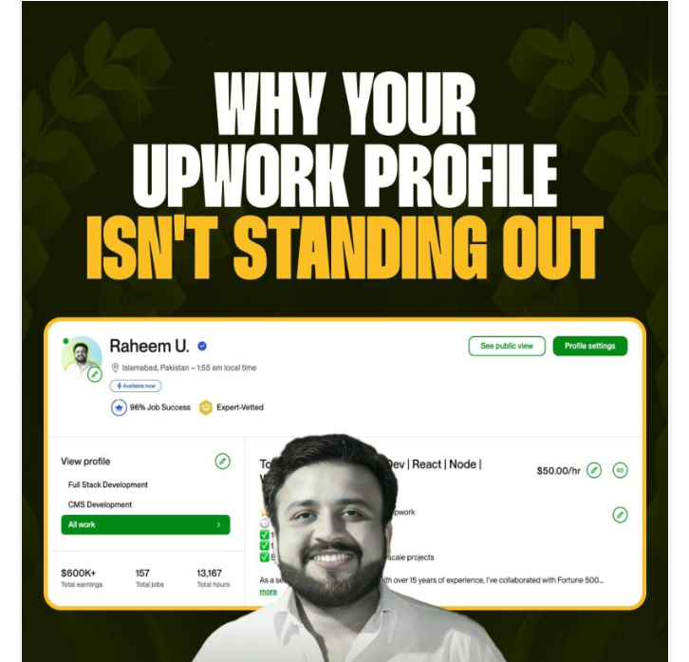

If you look at my Upwork profile, you'll see that I started with rates as low as $10 and have increased them over time with significant achievements. Clients can easily decide whether to work with me based on these top statistical milestones.

I cover many aspects of Upwork optimization in my live session, which you can watch below.

<https://www.youtube.com/live/F2X3NXEnd_A?si=tn3XNZg27M9g_Mco>

## 

## 

## 

## 

## 3- Build a Strong Portfolio

Create a professional portfolio showcasing your best work. This will help potential clients see your skills and previous projects.

Seven out of ten students have asked me the same question: "I have the skills, but where should I find clients for my portfolio? I always tell them to offer free services to build their portfolio and then showcase that work to potential clients.

For example, if you’re a digital marketer, run ads for yourself and use those results as part of your portfolio.

Many freelancers find themselves stuck in a cycle where they need a portfolio to attract clients, but they need clients to build their portfolios. Think outside the box and focus on doing the work, even if it’s initially unpaid until you’ve built a strong portfolio.

Platforms like Behance and Dribble can be useful for designers, while GitHub is great for developers.

You can check out my GitHub profile if you're a developer:

<https://github.com/raheemdawar>  
  
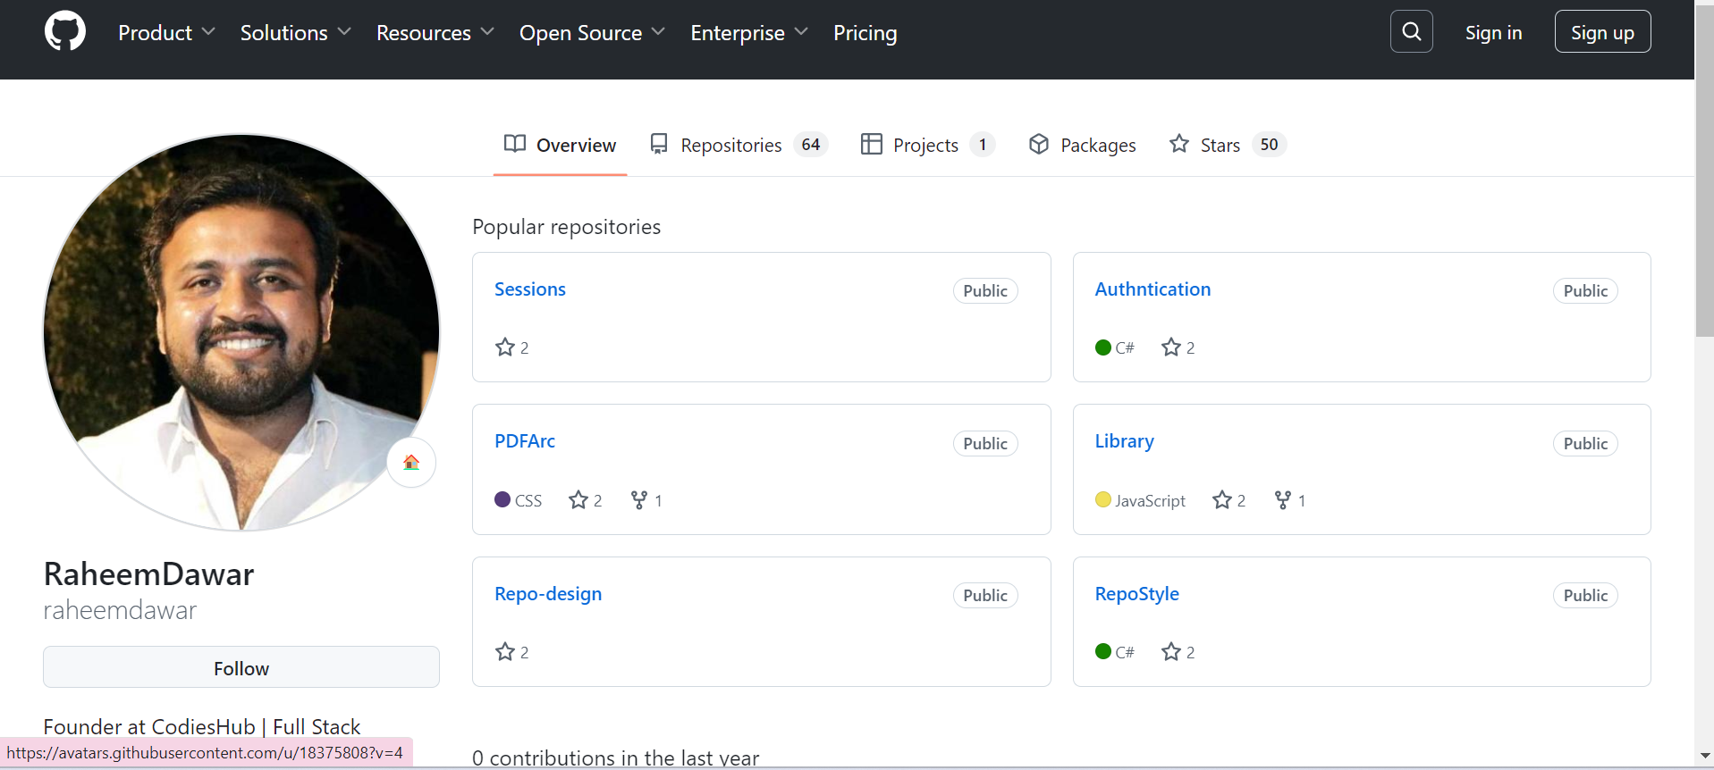

## 4- Deliver High-Quality Work and Communicate Well

Always deliver great work! For example, I once worked on a $500 project for a client. After delivering high-quality results and maintaining clear communication, the client continued to trust me with larger projects, ultimately paying me $200K over time.

You can see the post about the $200K project on my LinkedIn;

<https://www.linkedin.com/posts/raheemdawar_freelancer-upwork-tech-activity-7227279074782547968-GIFY?utm_source=share&utm_medium=member_desktop>

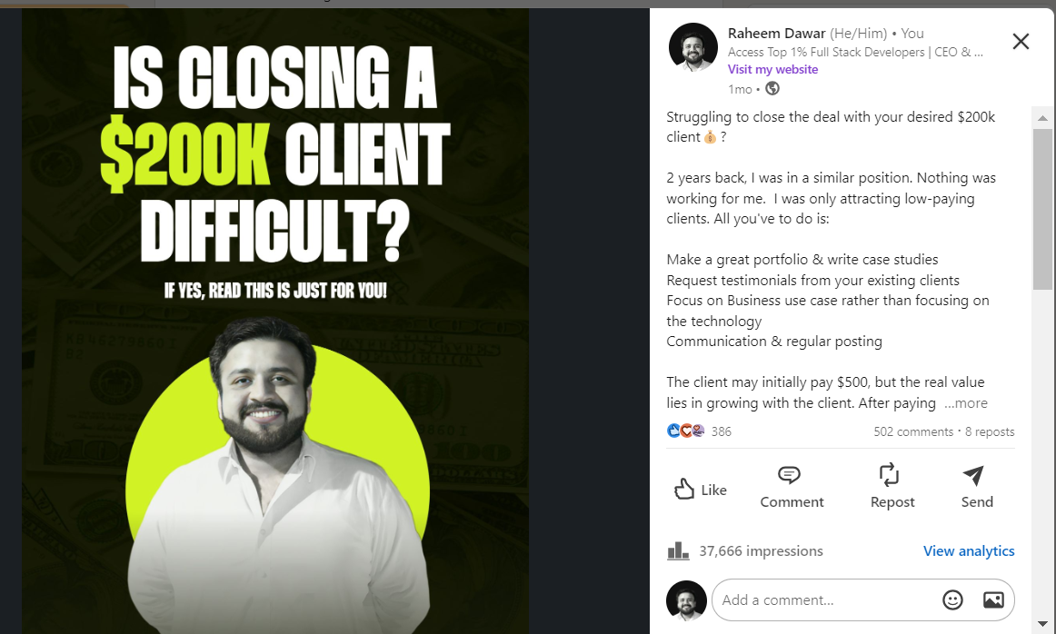

In remote work, communication is a key aspect that should be well understood and practiced. I recommend sending video recordings to clients, especially when they have concerns about language barriers. Visual explanations are often much clearer and more convincing than written communication.

My previous post about communication caught the attention of many freelancers. Here's the link to the post, where you can get an idea of the do's and don'ts in effective communication! :)

<https://www.linkedin.com/posts/raheemdawar_communicate-like-a-pro-activity-7196094438962561024-TS5e?utm_source=share&utm_medium=member_desktop>

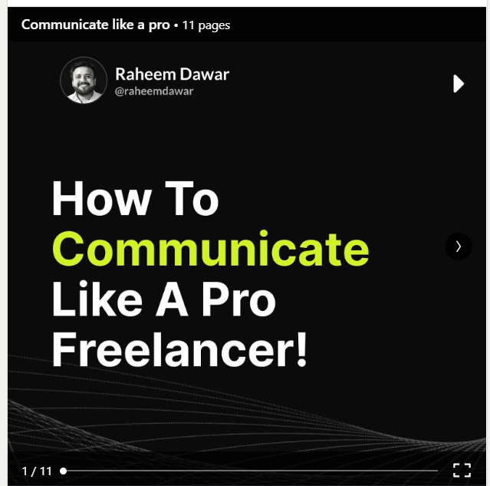

Note: Use tools like Slack for communication and Google Drive for sharing

Discover the top business development tools of 2024 in this concise guide, featuring Upwork, LinkedIn, Slack, Zoom, Zapier, Monday.com, Asana, and more which I use through the link below.

<https://youtu.be/YSULNgnDvpU?si=CMBebpR8WmG44Ow0>  
  
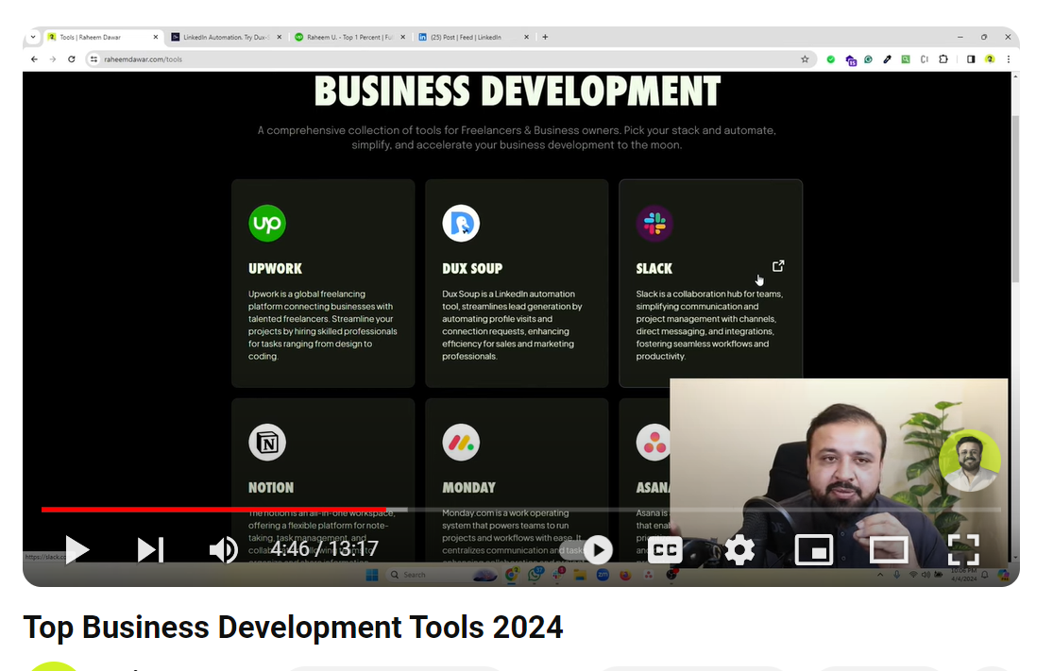

## 

## 

## 5- Invest in Continuous Learning

Freelancers who engage in continuous learning see a 40% increase in repeat business on Upwork. In the fast-paced world of freelancing on Upwork, staying relevant and competitive is key to success. Whether it's mastering new tools, staying updated on industry trends, or improving your skills.

Upwork constantly updates its features, including those related to profile visibility (like boosting profiles), project financials (such as direct client fees), and project continuity (like renewals).

To stay competitive in the market, it's important for freelancers and clients to be aware of these trends.

We offer various business development programs with an impressive success rate of nearly 90%. Below are the details of the different programs

# Our Programs

## Cohort 12 weeks program

Cohort is essentially a 3-month business development program in direct collaboration with Sir Raheem Dawar. In this program, you will receive hands-on experience and training to the extent that you can become an independent freelancer and grow your own agency, all while receiving guidance and support.   
  
In Cohort, we will begin with Upwork and then cover the most effective tools for client outreach and management. This includes email marketing, LinkedIn and its Sales Navigator, Apollo, CRM systems, Clutch, and Clay.

✅ 1-1 call with Raheem for profile review

✅ Weekly Zoom calls with Raheem

✅ $1000 challenge

✅ 24/7 support

Further details can be found by clicking the link below:  
  
<https://www.raheemdawar.com/offering/learn-from-us>

## 1-1 CEO mentorship program

In the 1-1 CEO Mentorship Program, our experts will guide you through the entire implementation process. The process involves email marketing, profile optimizations, cover letter writings, daily rechouts, client communication, conversion tracking, client delivery, and many more. During this program, we will communicate via Slack, available 24 hours a day.

✅ 1-on-1 Zoom Calls with our experts.

✅ 24-Hour Support through Slack.

✅ Raheem Will Review Everything at Every Step.

Further details can be found by clicking the link below:  
  
<https://www.raheemdawar.com/offering/hire-us-to-do-it-for-you>

# Next Steps :)

Let me help you for real!

If you have questions related to the Cohort or 1-1 CEO Mentorship program, you can reach out to our support via WhatsApp at +92306-9177064.

Share this post with fellow freelancers to help them achieve success too!

May your bank account get flooded with dollars, for real!